

High Level Foam Sensor Striving to offer the oilfield new solutions to old problems Direct Data Technologies has developed patent pending technology with its High Level Foam Sensor. This stand alone unit can shut down the well in a high foam situation and/ or start a chemical pump to inject defoamer into the tank with the option of tying into our Optitrol panel to send an alarm or call out.
Advantages
- Eliminates foam overs
and high level spills
- Use less defoaming chemical
- Easy installation through thief hatch
- May be tied into Optitrol or preexisting SCADA systems for alarming or callouts
- Adjustable height
- No hot tap required

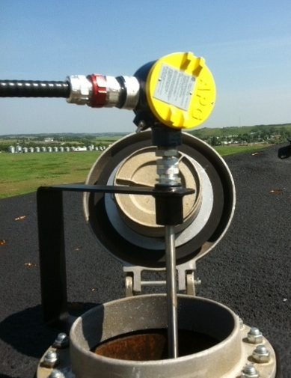
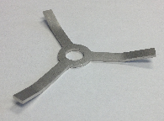

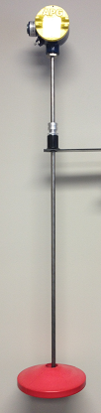
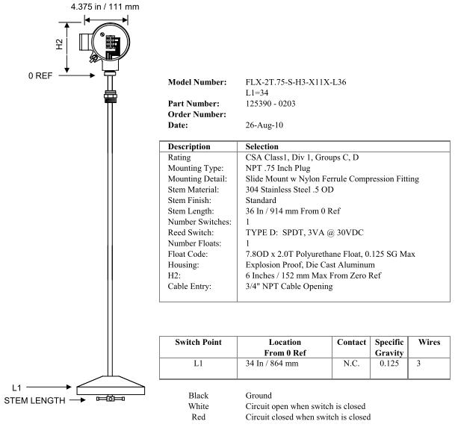
Direct Data Technologies Inc.
#8 6544 63rd ST Close
Lloydminster, AB
T9V 3C6

Three foot high level foam probe with .125 specific gravity foam float. (Custom Lengths Available)

“Work Smarter, Not Harder!”

